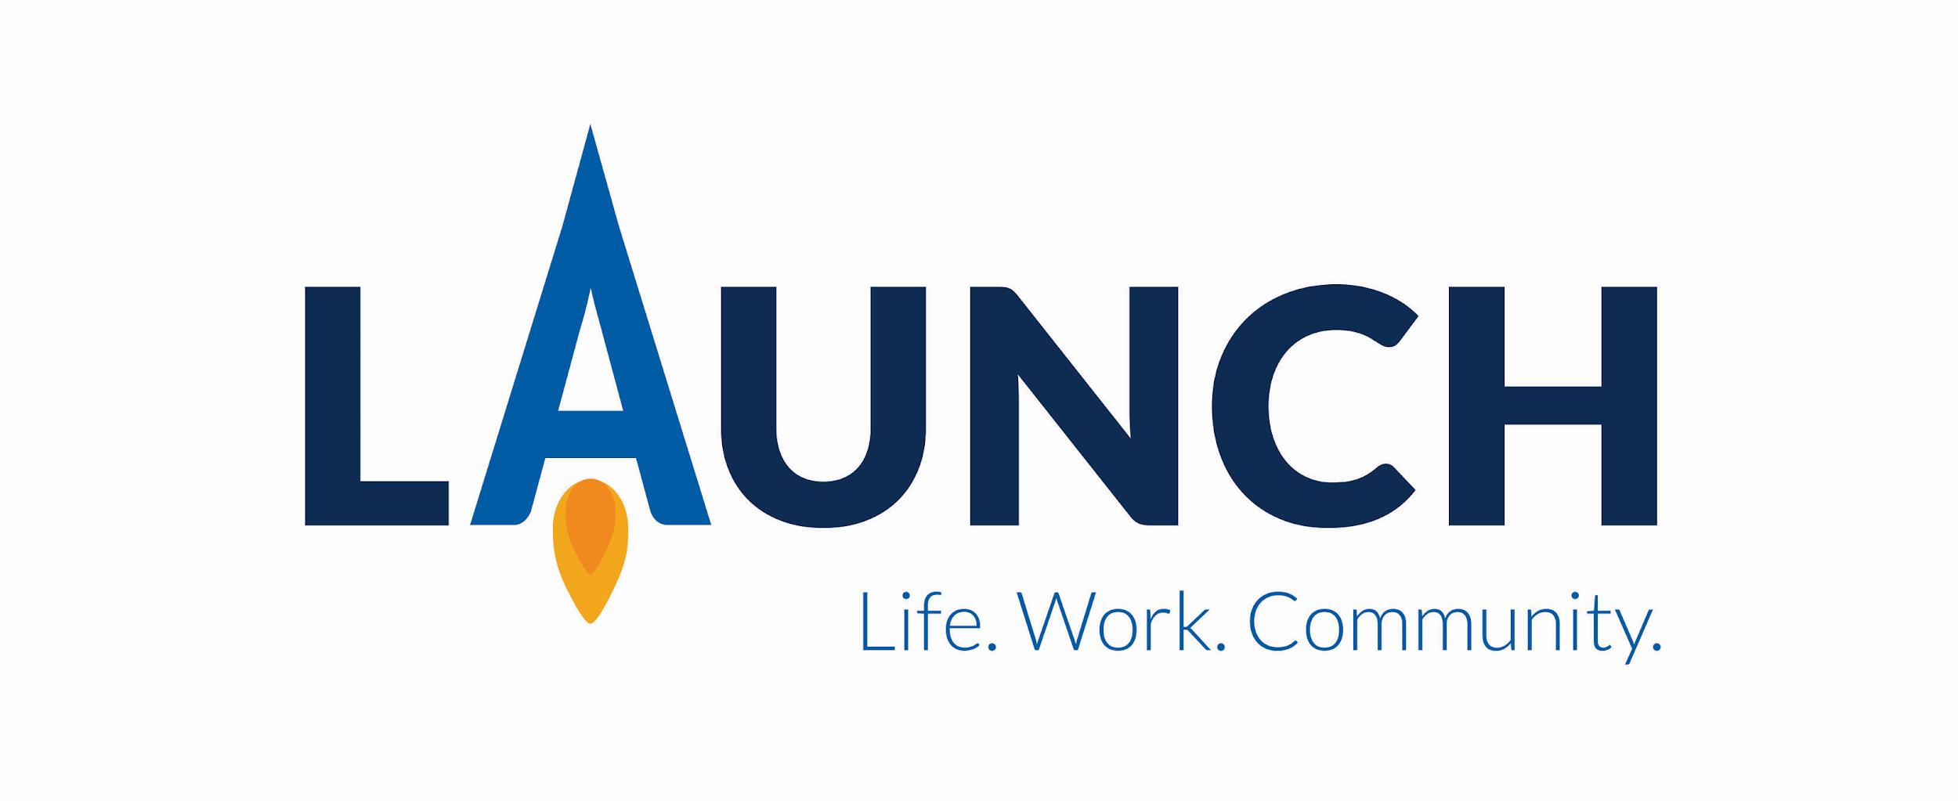

Explore Careers Day – December 1, 2021
Open House - December 2, 2021

Students identified with a disability, ages 18 years to 21, planning to earn all of their academic credits during the 2021-2021 school year, with the desire to enter competitive community employment, may want to sign-up for a tour of the Upper Valley Career Center Launch program.

Touring students, parents and staff need to arrive Dec 1 or 2, 2021 at Koester Pavilion, Lower Level where UVCC Launch is located.

High school and open-enrolled school staff members are also welcome to drive directly to the program for a tour. Please contact Patti K. Moore at 937-725-5501.

- Name of student__________________High school____________
- Parent/guardian’s name_________________________________
- Home address____________________Phone #_______________
- Staff contact & phone number_____________________________
- Please circle/check a tour and transportation:
- Dec 1 a.m. tour (9:30 a.m.)

Parent/guardian/ school drives directly to Koester

- Dec 1 p.m. tour (12:30 p.m.)

Parent/guardian drives directly to Koester

- Dec 2 (5:30 p.m)
Parent/guardian drives directly to Koester

- Please complete form
- Return to Upper Valley Career Center
  - Attention: Patti K. Moore, Launch Coordinator
  - 8811 Career Drive
  - Piqua, OH 45356

