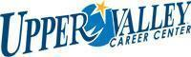
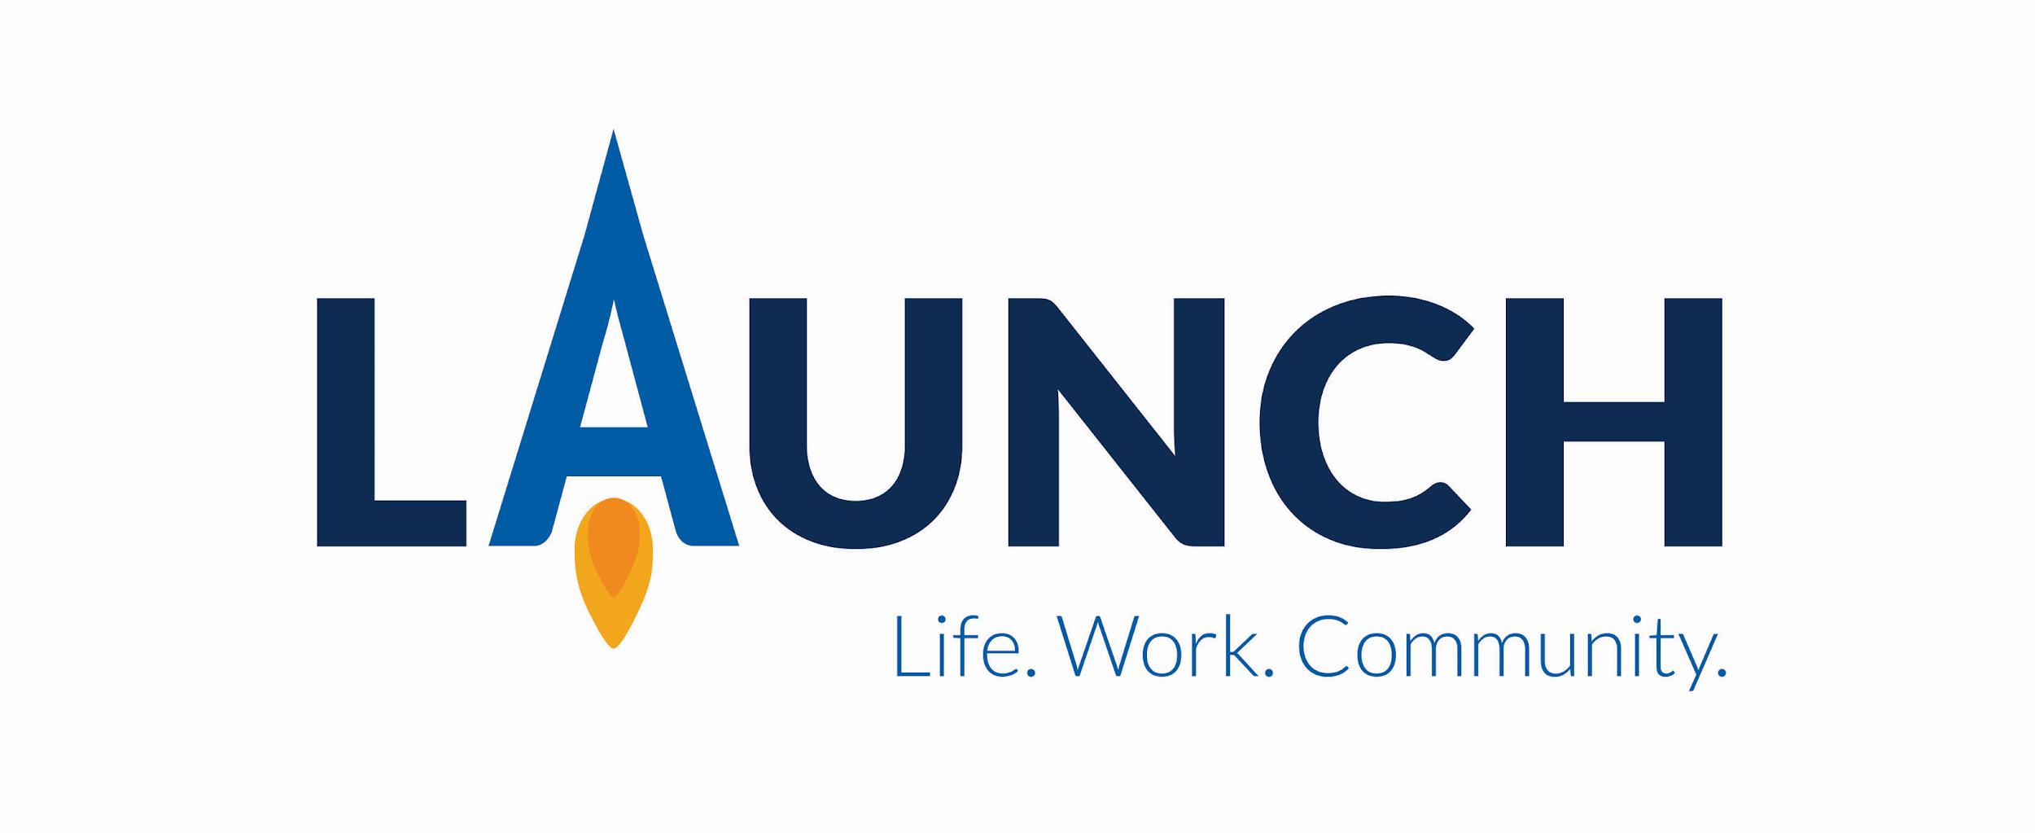

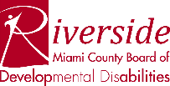

Upper Valley Career Center Launch is a one year, high school transition program which provides training and education leading to employment for individuals with disabilities. UVCC Launch serves as a workforce alternative for interns who have deferred their diploma and are in their last year of high school. Intern applicants gain admission into UVCC Launch through a selection committee process. The shared goal of all partners is competitive employment utilizing the skills built through the program.
Patti K. Moore- UVCC Launch coordinator
Upper Valley Medical Center
3130 N. County Rd 25A
Troy, OH 45373
937-726-5501

Fast Facts for Upper Valley Career Center Launch
Application Process
- Follow UVCC application timeline which begins Dec 2, 2021

- Student & Family Member schedules an UVCC Launch tour with
Patti K. Moore @ 937-726-5501 (group tours held Dec 1 & 2 , 2021)

3. Complete the Upper Valley Career Center Launch application
A. Must include current IEP, ETR & high school transcript

4. Complete Upper Valley Career Center student paperwork

5. Student schedules for an UVCC Launch interview/skill assessment.

