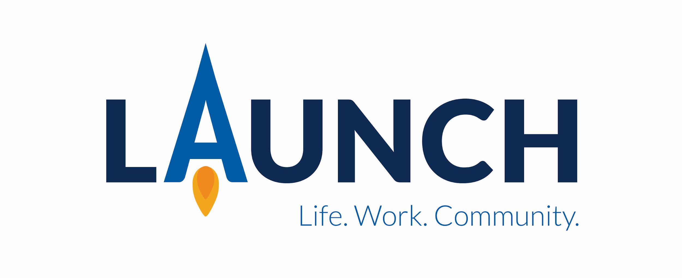

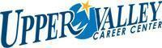

Greetings,
Enclosed you will find applications, Fast Facts and an Explore Career Day sign up form for students, families and staff desiring to tour and apply for the Upper Valley Career Center Launch 2022-2023 program.
We continue to welcome students, parents and educational professionals to tour Dec 1 & 2, 2021. Please complete the enclosed tour form to reserve a spot.
UVCC Launch is a unique business-led transition program designed for students with disabilities. It is targeted for students whose main goal is employment and will benefit from career exploration. The cornerstone of the one school-year program is the immersion of our partnership with Upper Valley Medical Center, Koester Pavilion and Outpatient Care Buildings. At these locations students learn employability and job skills while participating in a variety of worksite rotations that build skills toward competitive employment. Individualized job development and placement occurs based on the student’s experiences, strengths, and skills. Students are given support with accommodations, adaptations and on-the-job coaching.
For Further information, contact Patti K. Moore, UVCC Launch Coordinator at 937-726-5501.

Sincerely,

Patti K. Moore Becky Black
UVCC Launch Coordinator UVCC Launch Paraprofessional
